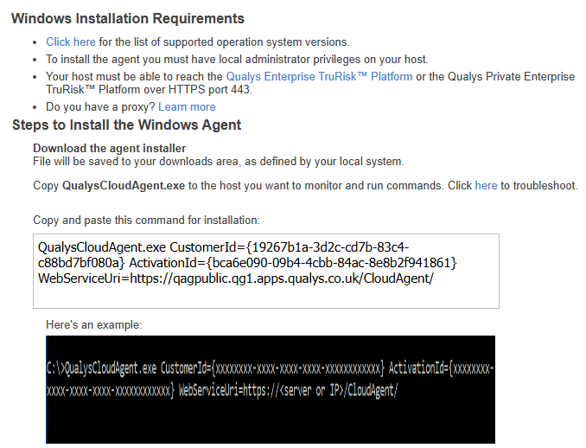

QualysCloudAgent.exe CustomerId={19267b1a-3d2c-cd7b-83c4-c88bd7bf080a} ActivationId={bca6e090-09b4-4cbb-84ac-8e8b2f941861} WebServiceUri=https://qagpublic.qg1.apps.qualys.co.uk/CloudAgent/

